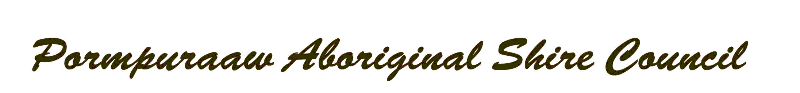
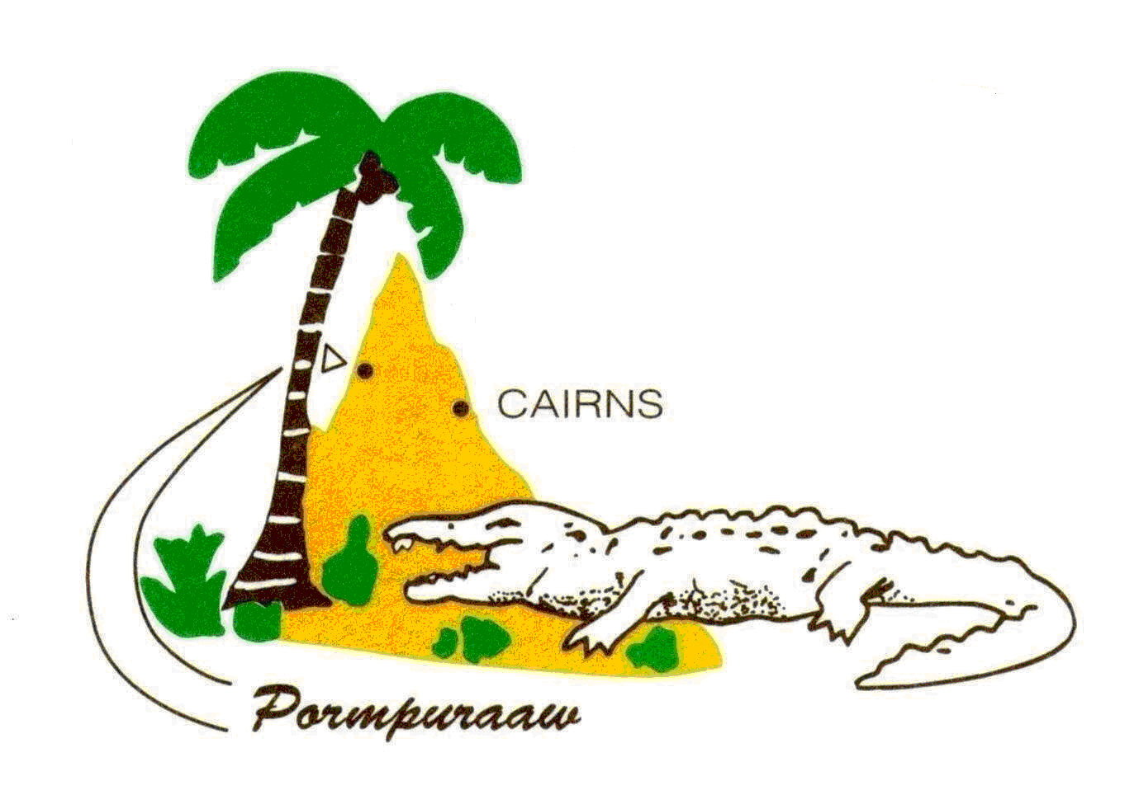

Customer Service Standards
Water and Sewerage Services

Pormpuraaw Aboriginal Shire Council (PASC) is located in the Western Cape Region of North Queensland. PASC administer local government function in the Deed of Grant in the Trust Area (DOGIT) for benefit of residents of Pormpuraaw.

- Customer Service Standards
PASC is responsible for providing water and sewerage services to residential, commercial and industrial customers.
PASC manages the water storage and is responsible for operating and maintaining water and sewerage assets throughout the Shire.

- What are my Obligations as a customer?
In order for us to deliver the best service to our customers and achieve the standards detailed in this document we will need to assist us by:
- Maintaining the pipe work and fitting within your property that connects you to our services
- Applying and receiving approval before connecting or disconnecting to our infrastructure
- Allowing our staff to access the property to carry out any repairs or modifications that may be required
- Using water in a water wise manner
- Our Responsibilities
We will comply with the standards set out in the Customer Service Standard when providing water supply and wastewater services to our customers.

The PASC Customer Standards apply in relation to:
- Day to day continuity of your water supply
- Provide and effective and high quality water supply system
- Ensure the continuity of water supply and sewerage services in the long –term
- Release affluent to environmental licence requirements
- Solving your water supply and sewerage problems effectively and without delay

  - Long Term Continuity of Services
PASC will take all reasonable action to provide its customers with reliable and continuous services. Council is committed to ensuring that water mains and sewers that are reaching the end of their useful life are replaced subject to availability of funds. Council aims to minimise the number of water mains leaks and breaks, reduce water loss in the system and reduce the number of breaks and blockages in the sewer system. This will be assisted by system monitoring and planned maintenance programs an will be enhanced by a major upgrade to the town water mains in 2015.
  - Planned and Unplanned Service Interruptions
For planned temporary service interruptions, such as maintenance of water mains, Council will provide affected customers with at least 48 hours notice of the type and timing of our activities.
Where Council is not able to provide prior notice, we will endeavour to restore your service as quickly and efficiently as possible to minimise inconvenience to affected customers.
  - Quality of Water Supply
- Adequacy and Quality of Normal Water Supply
The PASC aims to provide water which is suitable for consumption and meets the current Drinking Water Quality Management Plan 100% of the time. Generally sufficient water pressure shall be provided to all households.
Council will endeavour to ensure that potable water supplied:
- Meets the Australian Drinking Water Quality Guidelines
- Meets reasonable needs
- Is clear and free from objectionable odour and taste
- Meets legislative requirements of the Department of Energy and Water Supply

  - Sewerage Services
Council will endeavour to provide sewerage services that:
- Meet reasonable needs
- Avoids odours, overflow and interruptions
- Meet regulatory requirements
- Meets legislative requirements of Environment and Heritage Protection
Customer Service Standard
Council will develop new Customer Service Standard, in consultation with customers that sets target levels of service for a number of key performances indicators. As an existing drinking water services provider this need to be revised every 5 years.

CUSTOMER SERVICES PROCEDURES
Customer Connections
If you wish to apply for a water supply or sewerage service connection, you will need to submit an application form to Council.
Installation of a new service connection will usually take place 10 working days after receiving your application and the fee for the service. For further information regarding service connection please contact the Council Office.
- Minimising wastewater discharge, including fats, oils and grease from the premises
- Notifying us of any faults that you have encountered or complaints that you may have so that we can correct the problem as quickly as possible
- Maintaining private plumbing and drainage in accordance with the Plumbing and Drainage Act and Regulations

OUR CUSTOMER SERVICE STANDARDS
Council have developed customer service standards to address:
- Day-to-day Continuity of Your Water Supply.
- Adequacy and Quality of the Water Supply System.
- Effective Transportation of Sewerage Waste Effluent
The following sections provide a brief overview of our objectives in ensuring these customers service standards are met.

Day-to-day Continuity of Your Water Supply
We aim to provide continuous and reliable deliver of water supply to all our customers
At times, we may need to interrupt your water supply service to undertake maintenance and repair work. In these instances, we aim to provide you with at least 48 hours notice prior to the event.
Our water supply system may also be interrupted by acts outside our control. For unplanned events, we are unable to provide you any notice. If your service is affected, we aim to restore all interruptions with in 5 hours.
Council will continue to monitor water consumption through water metering and encourage water minimisation through its water charging policy and water usage awareness advertisements.
Forward planning strategies for future water sources have been considered in the Total Management plan and may be pursued as appropriate.
Sewerage Wastewater Services Performance Indicators
 | Performance Indicators | Performance Measure | Target
14 | Total sewerage overflows per year |  | 15
15 | Sewerage overflows to customer properties |  | 15
16 | Odour complaints |  | 20
17 | Response/reaction time to incidents (all events) | Response to all events < 24 hours | 98%
18 | Response/reaction time to incidents (emergency) | Response to emergency < 1 Hour | 98%
Billing and Accounting
Water and sewerage charges are levied at the same time your general rates are levied. This occurs twice per year. The terms for payment are stated on the notice and there is a penalty for late payment.
Water charges include an annual allocation. Water usage over and above this allocation is billed in the first rates notice of the financial year. All water sewerage fees and charges are billed in accordance with Councils prescribed fees and charges. These fees and charges can be viewed at the Council office. Should you have any queries regarding you bill you can speak to the rates clerk at the Councils Office.
Metering
It is Councils policy that all properties connected to the water supply are metered. The meter will be accurately measure the quality of water consumed by your household and the reading is used to calculate your bill. If you are concerned about the accuracy of your reading you should contact the rates clerk at the Council Office.
Interruptions
We will minimise interruptions to your supply during peak demand periods, and will provide a minimum 48 hours notice for planned interruptions.
We will complete work as quickly as possible to minimise disruption to your daily activities where unplanned events occur.
We will minimise the likelihood of interruption occurring to schools, hospitals and medical centres and will ensure priority is given to hospitals in case of a water interruptions.
- Being “Water Wise”
- Maintaining the pipe work and fittings on private property
- Taking care not to discharge any unauthorised substances into sewers
- Providing access to manholes and water meters as required
- Notifying Council of any faults encountered so that problems can be rectified as quickly as possible
- Driving carefully through our construction/worksite

Customer Assistance
PASC is committed to the on-going improvement of customer service and welcomes any comments, complaints, enquiries and suggestions. How to contact us:

Telephone | 40 604-600
In Person | Council Office  24 Thinraathin St  Pormpuraaw  Open: Monday to Friday – 8.00am til 12.00pm – 1.00pm til 4.15pm
Email | Admin@pormpuraaw.qld.gov.au
Online | www.pormpuraaw.com.au
Mail | Chief Executive Officer  P.O Box 15120  Edge Hill 4870

In the event of an Emergency Please contact: Environment Manager on 0458 001 051.

